User Enablements Conversion Test
Note: Currently in CBOE-Direct system, user authorization is stored in form of disablements for sessions. With the new enhancements due to hybrid requirements, the new authorization will be based on user enablements, by session and operations. Therefore, conversion utility is needed to convert existing disablements into enablements using the property service.

Requirements:

run_dir\properties\UserEnablementConversion.properties
run_dir\bin\UserEnablementConversion

Usage:
…run_dir>UserEnablementConversion

Testing Conversion Utility
Number | Description | Expected Results | Expected Results Achieved?
 | Select the “User Maintenance” option from the start menu | A window similar to the figure above appears
 | Select the user MAA in the user tree. | The panels on the right display the information for the selected user.
 | Select the Enablements tab | The enablements tab appears.
 | Select the Trading Session drop down and verify NO sions appear in the list | No sessions appear in the list
 | Run the conversion utility | UserEnablement Conversion completed (takes approx. 60 minutes)
 | Select the Trading Session drop down and verify all sessions appear in the list | All sessions appear in the list

SA GUI Test

Login

Number | Description | Expected Results | Expected Results Achieved?
 | Login to SA GUI using valid help desk ID. | Login Successful

User Enablements

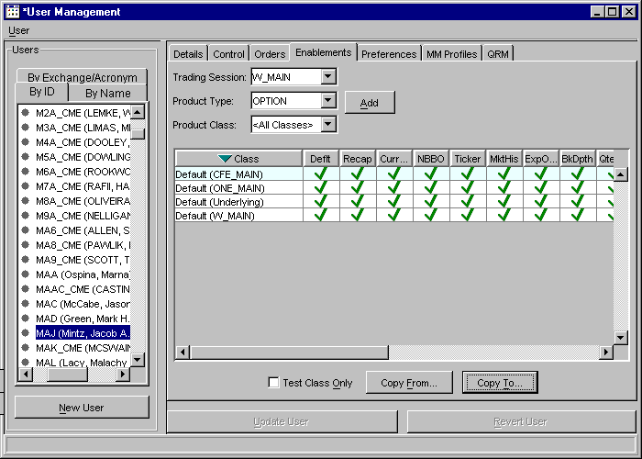
Figure 1 User Enablements

User Enablements Notes
- This test requires the use of 3 Market Maker userids. For the purpose of this test, the market maker users used were MAA, MAC and MAD. Any three users with a role of market maker can be substituted for them. The test plan will refer to these three ids by the Acronym, substitute the three acronyms in the test plan, if you use different ones.
- This test requires the use of 2 Help Desk userids. For the purpose of this test, the help desk users used were HD2 and HD3. Any two users with a role of help desk can be substituted for them. The test plan will refer to these two ids by the userid, substitute the two userids in the test plan, if you use different ones. The help desk users must have full enablements for all sessions.
- Sessions and classes may be different in each environment. Any session and/or Class can be substituted. Do not substitute the same session or class for two different sessions or classes in the same test.
- For the following tests, it is best to have two GUIs active, a SA GUI and a Trader GUI. Instructions for the SA GUI will be prefaced with [SA] and instructions for the Trader GUI will be prefixed with [Trader]. If the test does not contain any identification, the whole test is for the SA GUI.

1. Testing Basic Enablement GUI
Number | Description | Expected Results | Expected Results Achieved?
 | Select the “User Maintenance” option from the start menu | A window similar to the figure above appears
 | Select the user MAA in the user tree. | The panels on the right display the information for the selected user.
 | Select the Enablements tab | The enablements tab appears.
 | Select the Trading Session drop down and verify all sessions appear in the list | All sessions appear in the list
 | Select a session | The Product Type and Product Class combo boxes get default values. The Product Type will show a valid Product Type and the Product Class will show “<All Classes>”
 | Select a Product Class from the combo box that is not already in the enablement list. | Selected Product Class shows in the combo box.
 | Press the add button | The enablement for the Session and Class is added to the table. The “Update User” and “Revert User” buttons become enabled.
 | Press the “Revert User” button and press “Yes” on the confirmation dialog | The row is removed from the table and the Update and Revert buttons become disabled.
 | Press the add button to add the enablement. | The enablement for the Session and Class is added to the table. The Update and Revert buttons become enabled.
 | Press the “Update User” button | The user is updated and the screen switches back to the Details tab
 | Click the Enablements tab | The enablements tab appears. Verify the list of enablements contains the original list, plus the new enablement added.
 | Click on the new enablement to select the row in the table. | The row becomes highlighted
 | Right-Click on the selected row, which contains the new enablement | A Pop-Up menu appears with the options “Enable All”, “Invert Enablements” and “Remove”
 | Select “Remove” from the menu. | The row is removed from the table. The Update and Revert buttons are enabled
 | Press the “Revert User” button. | The row is added back into the table and the Update and Revert buttons are disabled
 | Select the new row, Right-Click and select “Remove” from the menu. | The row is removed from the table.
 | Select the “Update User” button | The enablements are saved and the tab switches to the details tab.
 | Select the Enablements tab. | Verify the new row is not contained in the table with the list of enablements
 | Double click on one of the cells in the table with a green check. | The green check changes to a red x. The Update and Revert buttons become activated.
 | Press the Update button, followed by Confirm | Verify the change is saved ant the cell is still unchecked.
 | Double click the cell with the red X | The red X changes to a green check. The Update and Revert buttons become active
 | Press the Update button followed by confirm. | Verify the change is saved and the cell is checked.
 | Select a row in the enablements table | Row is selected
 | Modify the row to contain some enablements on (red X) and some off (green check). | Selected row contains a mix of enablements
 | Right-Click on the row to bring up the pop-up menu | A Pop-Up menu appears with the options “Enable All”, “Invert Enablements” and “Remove”
 | Select “Invert Enablements” from the menu | Verify all the enablements were inverted for the selected row only.
 | Right-Click on the row to bring up the pop-up menu and select “Enable All” | Verify all the enablements were enabled for the selected row.
 | Select the user “MAC” in the user tree. | Dialog appears stating that you have unsaved changes and asking if you wish to save them.
 | Press the “Yes” button on the dialog. | Screen saves and switches to the new user
 | Select the user “MAA” in the user tree and select the enablements tab. | Verify the changes were saved.

Testing Enablement Copy GUI
Number | Description | Expected Results | Expected Results Achieved?
 | Edit the user MAA to have the following enablements and save the changes.  W_MAIN/AOL/all  W_MAIN/IBM/Deflt only  W_AM1/Default/all | User MAA shows the enablements
 | Edit the user MAC to have the following enablements and save the changes.  W_MAIN/IBM/all  W_AM1/DJX/all | User MAC shows the enablements
 | Select the user MAA | User MAA shows
 | On the enablements tab for MAA, select the Copy From button. | Copy Enablements From User dialog shows.  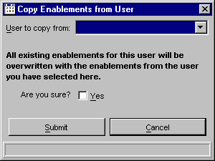
 | Type “MAC” in the “User to copy from” combo box.. | User MAC shows as selected in the combo box
 | Do Not select the confirmation check box and press the “Submit” button. | Dialog closes and enablements for user MAA remain unchanged.
 | Select the Copy From button | Copy enablements from user dialog shows
 | Select MAC from the dropdown in the combo box | User MAC shows as selected in the combo box
 | Select the “Yes” check box. | Check box shows a check in it
 | Press the submit button and press confirm | Dialog closes and user is taken back to the enablements tab, where the enablements have been changed to exactly what user MAC had. Verify from list above.
 | Edit the user MAD to have the following enablements and save the changes.  W_MAIN/Default/all  W_AM1/NDX/NBBO only | User MAD shows the enablements
 | Edit the user MAA to have the following enablements and save the changes.  W_MAIN/AOL/all  W_MAIN/IBM/Deflt only  W_AM1/Default/all | User MAA shows the enablements
 | Select the user MAD and go to the enablements tab | User MAD enablements show
 | Press the Copy To button. | Copy Enablements To Users dialog shows
 | Type MAC in the combo box | User MAC shows selected
 | Press the “Select >” button | User MAC shows in the “Users Selected” list box
 | Select MAA from the Users combo box | User MAA shows selected
 | Press the “Select <” button | User MAA shows in the Users Selected list box
 | Do Not check the “Yes” confirmation checkbox and press Submit, then Confirm | Dialog closes and takes the user back to the enablements screen for MAD. Select the users MAC and MAA and verify no changes.
 | Press the Copy To button. | Copy Enablements To Users dialog shows  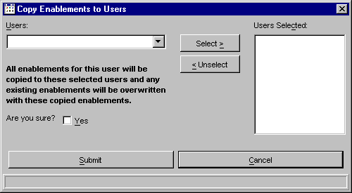
 | Type MAC in the combo box | User MAC shows selected
 | Press the “Select >” button | User MAC shows in the “Users Selected” list box
 | Select MAA from the Users combo box | User MAA shows selected
 | Press the “Select <” button | User MAA shows in the Users Selected list box
 | Check the “Yes” confirmation checkbox | Yes confirmation check box has a check in it.
 | Press the Submit button, then Confirm | Dialog closes and copy to report dialog opens.  Verify new Enablements are listed for MAD.  Verify old enablements are listed for MAA and MAC and they are correct.
 | Select the enablements tab for user MAA and MAC | Verify the enablements are the enablements from MAD
 | Start up a second SA GUI and log in as a different help desk user. | Logged in
 | Select “User Management” from the start menu | User Management opens
 | Select the user MAA and select the enablements tab. | User MAA is shown
 | Add the enablement W_MAIN/ORCL/all  Do not save. | The enablements shows on the table
 | Back on the first GUI, select the user MAA and select the enablements tab. | User MAA shows without the new enablement
 | Still on the first GUI, add the enablement W_MAIN/AMD/all | The enablement shows on the table
 | Still on the first GUI, press “Update User” | The enablements save and the GUI switches back to the details tab
 | Still on the first GUI, select the enablements tab | The enablements tab shows only W_MAIN/AMD added.
 | View the second GUI. | A dialog has appeared on the second GUI notifying the user that changes were made.
 | On the second GUI, select the enablements tab | The list of enablements is identical to the list on the first GUI
 | For the following tests, it is best to have two GUIs active, a SA GUI and a Trader GUI. Instructions for the SA GUI will be prefaced with [SA] and instructions for the Trader GUI will be prefixed with [Trader]

Testing Enablements
Number | Description | Expected Results | Expected Results Achieved?
 | [SA] Login to the SA GUI with a help desk userid and start User Management | User Management window appears.
 | [SA] Setup user MAC with the following enablements. Remove all other enablements.  W_MAIN/default/All | User MAC shows the enablements
 | [Trader] Start a trader GUI and log in as MAC | Trader tool bar shows
 | [Trader] Select “Book Depth” from the start menu | Book depth screen shows
 | [Trader] Select a product in W_MAIN and press “Submit” | Book depth for the product is shown
 | [Trader] Select a product in W_AM1 and press submit. | Dialog appears with an AuthorizationException
 | [SA] Modify the enablements for MAC. Change the enablement for W_MAIN/default/Book Depth to disabled (red X). Save the changes. | Verify the new enablements are saved.
 | [Trader] Select a product in W_MAIN and press submit. | Dialog appears with an AuthorizationException
 | [SA] Add an enablement for MAC and save.  W_MAIN/AOL/All | Verify the new enablement is saved
 | [Trader] Select a product for Class AOL in W_MAIN and press submit | Book depth for the product is shown

Testing Enablements CMI calls (Test for CAS enablement code)
Number | Description | Expected Results | Expected Results Achieved?
 | Setup user MAC to have an enablement for  W_MAIN/AOL/All | Verify the user enablements are setup correctly
 | Edit the ACLTester.properties file to use the user MAC, session W_MAIN and class AOL.
 | Run the ACLTester program | Verify no AuthorizationException occurs
 | Individually turn off a single operation type in the enablements.
 | Run the ACLTester program | Verify that AuthorizationException is thrown for the appropriate methods. Below is the table of operation types and methods.
 | Repeat until all operation types have been tested

API | Method | OperationType
SystemMarket  QueryImpl | getBookDepth | MARKETQUERY_BOOKDEPTH
 | getMarketDataHistoryByTime | MARKETQUERY_MARKETDATAHISTORY
 | getBookDepthDetails | MARKETQUERY_BOOKDEPTH
 | subscribeRecapForClassV2 | MARKETQUERY_RECAP
 | subscribeRecapForClass | MARKETQUERY_RECAP
 | subscribeRecapForProductV2 | MARKETQUERY_RECAP
 | subscribeRecapForProduct | MARKETQUERY_RECAP
 | subscribeCurrentMarketForProduct | MARKET_QUERY_CURRENTMARKET
 | subscribeCurrentMarketForProductV2 | MARKET_QUERY_CURRENTMARKET
 | subscribeCurrentMarketForClass | MARKET_QUERY_CURRENTMARKET
 | subscribeCurrentMarketForClassV2 | MARKET_QUERY_CURRENTMARKET
 | subscribeNBBOForProductV2 | MARKET_QUERY_NBBO
 | subscribeNBBOForProduct | MARKET_QUERY_NBBO
 | subscribeNBBOForClass | MARKET_QUERY_NBBO
 | subscribeNBBOForClassV2 | MARKET_QUERY_NBBO
 | subscribeBookDepthForClass | MARKETQUERY_BOOKDEPTH
 | subscribeBookDepthForClassV2 | MARKETQUERY_BOOKDEPTH
 | subscribeBookDepthForProduct | MARKETQUERY_BOOKDEPTH
 | subscribeBookDepthForProductV2 | MARKETQUERY_BOOKDEPTH
 | subscribeBookDepth | MARKETQUERY_BOOKDEPTH
 | subscribeBookDepthUpdate | MARKETQUERY_BOOKDEPTH
 | subscribeTickerForClassV2 | MARKETQUERY_TICKER
 | subscribeTickerForProductV2 | MARKETQUERY_TICKER
 | subscribeTicker | MARKETQUERY_TICKER
 | subscribeExpectedOpeningPriceForClassV2 | MARKETQUERY_EXPECTEDOPENINGPRICE
 | subscribeExpectedOpeningPriceV2 | MARKETQUERY_EXPECTEDOPENINGPRICE
 | subscribeExpectedOpeningPriceForProductV2 | MARKETQUERY_EXPECTEDOPENINGPRICE
Intermarket  QueryImpl | getIntermarketByClassForSession | DEFAULT_OPERATION
 | getIntermarketByProductForSession | DEFAULT_OPERATION
UserOrder  QueryImpl | getOrdersForSession | ORDERQUERY **
 | getPendingAdjustmentOrdersByProduct | ORDERQUERY
 | getPendingAdjustmentOrdersByClass | ORDERQUERY
UserOrder  EntryImpl | acceptOrder | ORDERENTRY_ORDER
 | acceptOrderByProductName | ORDERENTRY_ORDER
 | acceptOrderCancelRequest | ORDERENTRY_ORDER
 | acceptOrderUpdateRequest | ORDERENTRY_ORDER
 | acceptOrderCancelReplaceRequest | ORDERENTRY_ORDER
 | acceptRequestForQuote | ORDERENTRY_RFQ
 | acceptCrossingOrder | ORDERENTRY_ORDER
 | acceptStrategyOrder | ORDERENTRY_ORDER
 | acceptStrategyOrderUpdateRequest | ORDERENTRY_ORDER
Product  DefinitionImpl | acceptStrategy | PRODUCTDEFINITION **
UserQuoteImpl | acceptQuote | QUOTE_QUOTEENTRY
 | acceptQuoteForClass | QUOTE_QUOTEENTRY
 | getQuote | QUOTE_QUOTESTATUS
 | cancelQuote | QUOTE_QUOTEENTRY
 | cancelAllQuotes | QUOTE_QUOTEENTRY
 | cancelQuotesByClass | QUOTE_QUOTEENTRY
 | subscribeRFQ | QUOTE_RFQ
 | subscribeRFQV2 | QUOTE_RFQ
TradingSession  BaseImpl | getStrategiesByComponent | TRADINGSESSION
TradingSession  Impl | getProductsForSession | TRADINGSESSION
 | getStrategriesByClassForSesison | TRADINGSESSION
 | getClassBySessionForKey | TRADINGSESSION
 | getProductBySessionForKey | TRADINGSESSION
 | getStrategyBySessionForKey | TRADINGSESSION
 | getClassBySessionForSymbol | TRADINGSESSION
 | getProductBySessionForName | TRADINGSESSION
UserHistory  Impl | getTraderProductActivityByTime | USERHISTORY
 | getTraderClassActivityByTime | USERHISTORY

** - These methods always use the default class instead of any specific class.

